Work plan

Deadlines
- 2015-03-02 Choose a project proposal and send the result via email to epsatisep@gmail.com
- 2015-03-11 Define the Tasks (what must be done), Task allocation (who does what) and Gantt chart (when) of the project and insert them on the wiki (planning)
- 2015-03-27 Specify the list of material (what, quantity, where to buy - local companies are mandatory) on the wiki
- 2015-04-05 Upload the Interim Report and Presentation to the wiki; the report should contain the Introduction, including the tasks, team members allocation and Gantt chart, State of the Art, Marketing Plan, Project Management, Eco-eficiency Measures for Sustainability, Ethical and Deontological Concerns, Proposed Solution and Bibliography chapters
- 2015-04-09 Interim Presentation, Discussion and Assessment
- 2015-06-12 Upload the Final Report, Presentation, Video, Paper, Poster and Manual
- 2015-06-18 Final Presentation, Individual Discussion and Assessment
- 2015-06-25:
  - Update the wiki with all correction suggestions
  - Hand in a CD with the corrected deliverables (source + PDF) together with all code produced to the EPS coordinator
  - Hand in one printed exemplar of the corrected report to the EPS coordinator
- 2015-06-26:
  - Hand in the prototype and user manual to the client
  - Receive the EPS@ISEP certificate

Tasks
Task | Responsible
meetings | all
plannings | all
research
material | Paloma
technologies | Bartek, Eughan
identity | Anthony
life-cycle | all
requirements | all
target | all
brief
identity | Anthony
objectives | all
implementation
marketing | Carina
materials | Paloma, Eughan, Bartek
programming | Eughan, Bartek
construction | Paloma, Carina
safety | all
testing/controlling
distribution
internet | Anthony, Carina, Kristjan
marketing | Carina

Gantt Chart
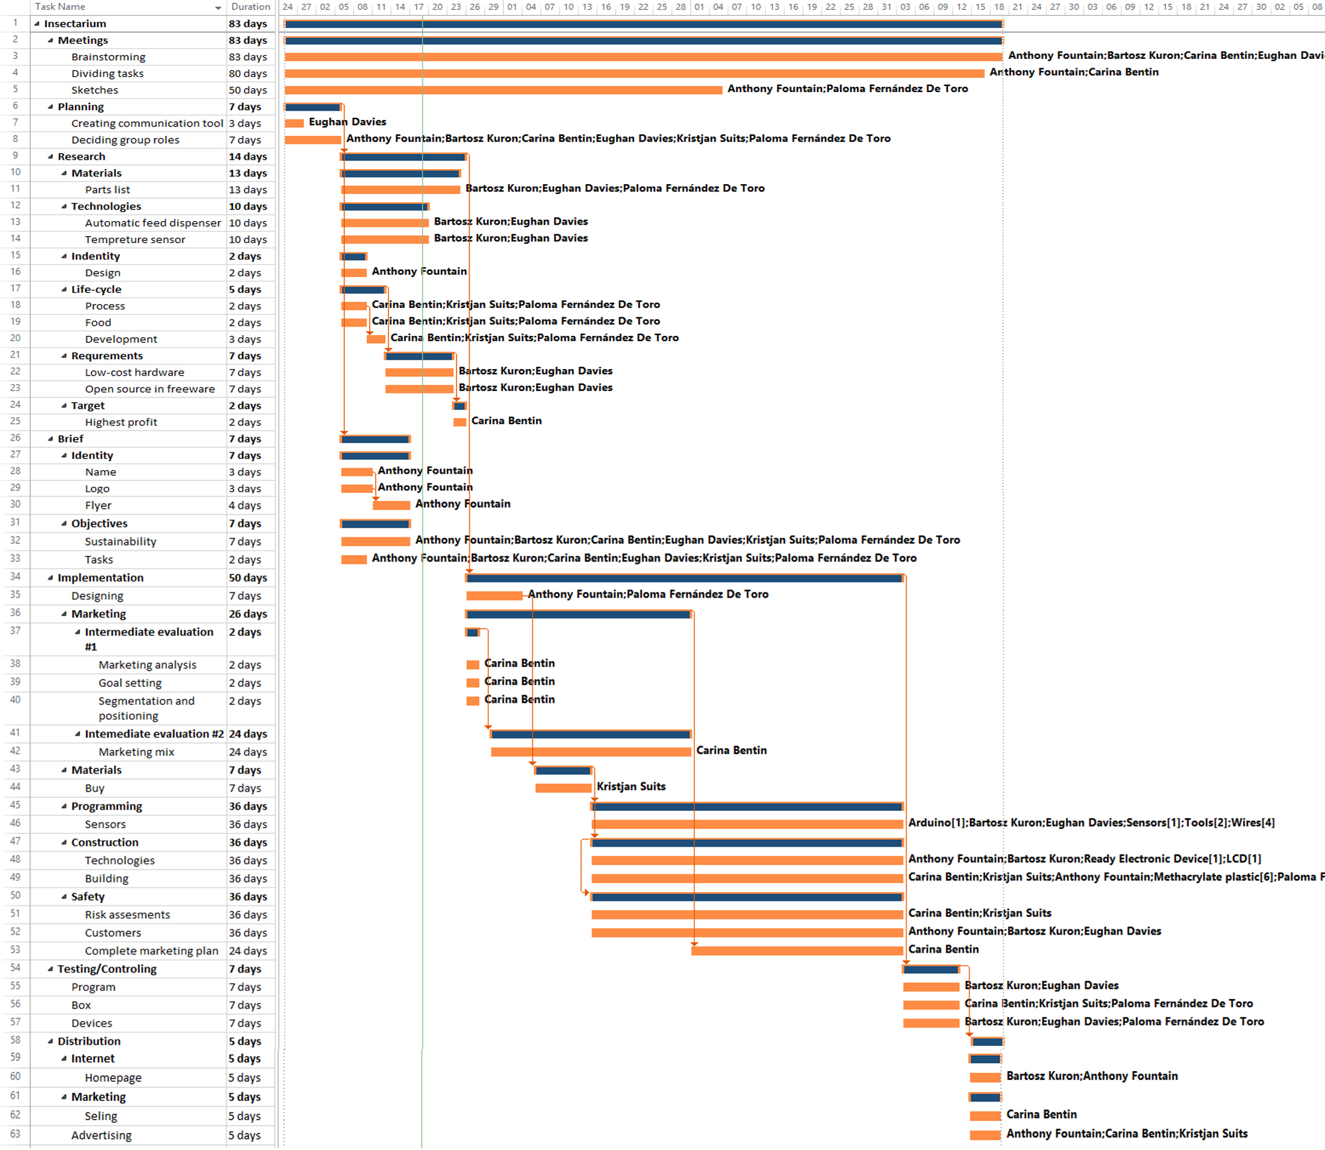
WEEK 22/06/2015 - 26/06/2015 GANTT CHART


