Weekly Report

1st Week Report (23.02.2015-01.03.2015)
In the last week, which was our first week, we couldn´t do very much. We got our topic for the EPS for the following months. So we sat together and every member wrote his or her favourite topics. The upside was, that our decisions clashed itself. So we found a topic and we thought about our next meeting, when it will be. That was our 1st week.

2nd Week Report (02.03.2015-08.03.2015)
Talked about the first ideas of the insectarium. It was just like a brainstorming. We discussed our approach and noticed a few questions that were divided to the group members for researching to bring new and further information and facts for the next meeting next day: - Which insects we chose? - Which size should our gadget have - Where/ how do the insects live and grow - Which country - Why and for whom we build this - What kind of processing with the insects
Than we discussed about the company´s name, which was difficult, because many names were copyrighted, so we made a list at Facebook to check, which every member likes most. So we actually found a name. Next step was to find our target-group which was also difficult. Is our gadget for the farmers, who feet their animals or is it for the private human, who just eat it because of the specialty and hunger.We want to drag as most profit as possible out of the selling of our insectarium. So we end the discussion for this day and made a research for oneself for the next meeting. Everyone had to think about questions for the supervision. - After the meeting we discussed about our new points of view about or project - We talked about the tasks, each has to do for the next meeting to go further, e.g. design, mealworms, electronic gadgets

3rd Week Report (09.03.2015-15.03.2015)
Many members were ill so we tried to communicate via Facebook. But we still come further when we do some material research, a design planning, made the Gantt Chart and our leaflet. After the meeting we decided to design and plan a new kind of insectarium, with different sections for the mealworms what already need a special research. Furthermore we added many things on the wiki and wait for a meeting with our coordinator Abel.

4th week report (16.03.2015-22.03.2015)
After the meeting Abel we had a new point of few and had to design a new kind of inectarium. So we did. Furthermore we finished the selection for the devices that should be installed on the insectarium. So everybody got a new task for home and we met again. After meeting with all supervisors we became clear, that we have to decide fastly, which materials we need. But the problem was, that we don´t have the final design. So everybody got tasks again, to finish the work. Also fot the wiki topics. That was also a mainpoint, we are all working on hardly because of the interim presentation. Furthermore we need to prepare a presentation for the last energy and sustainability course. So everyone has enough to do at home till monday. Because on tuesday we will write a test, and on thursday the material list has to be finished, because than are holidays.

5th week report (23.03.15-29.03.15)
We tried to write as much as possible into the wiki, because of the interim report and because of some lessons, that had a deadline. We extended the Gantt Chart and made a presentation in Energy and Sustainability. Furthermore we had some conversations with the clients because of the devices that should be installed in our insectarium. Eughan and Bartek came to a decision. And we now have a drawing of the idea how our product should look like.

6th week report (30.03.15-05.04.15)
Easter Holidays:
Add something into wiki and discussed on facebook for the presentation.

7th week report (06.04.15-12.04.15)
We worked on the Interim Report to make it fine and completed as much as possible in the wiki. We made the design and tried to position the divices on the intectarium. Theoretical at first.

8th week report (13.04.15-19.04.15)
We worked hard for the improvement of the wiki what was demanded from the teachers in the Interim Report. We worked on the final material list, on the dimensions and the positioning of the devices. Furthermore we choose new devices for the insectarium and met with the client for discussing that.

9th week report (20.04.15-26.04.15)
In this week we worked hard by improving the wiki and purge all mistakes. Everyone for his or her part. Furthermore Eughan make much research for the electrical devices, while Paloma decided where these should be installed at the insectarium. We all have to try finishing the wiki, for having time to build, install and test the insectarium when the materials arrived. Some started with the summary for the paper. And Anthony start with designing the poster and video. At last we have to upload some project managament tables, we also finished it in this week.

10th week report (27.04.15-03.05.15)
This week we worked on the material list for finishing. Then we had a guest teacher who told us much about the paper and in the end of the lesson she helped us by writing the abstract part of the paper. Another teacher came on thursday to fill the decision in the bibliographie in the wiki and who helped us with the techniques to optimize our report. We start with the design and collect some ideas for the video and for the poster we should prepare till june. All of us are anxious to improve the wiki documentation and fill the gaps which are still missing.

11th week report (04.05.15-10.05.15)
Queima da Fitas
building the card board

12th week report (11.05.15-17.05.15)
This week we were collecting materials and electronic devices. We also went to few shops to ask about prices of PMMA and Acrylic Glue, but finally we decided to use PVC because it is significantly cheaper and the quality of PVC is comparable. Moreover, it is easier to cut and use PVC. We were also looking for a shop to buy a sticker to stick it on PVC to make it more user friendly. We started to prepare code for our electronic devices.

13th week report (18.05.15-24.05.15)
This week we finished our material list and the supervisors offered it. We hardly worked on the paper, poster and video. With a bit help of teachers. We discussed about these things which is the best one. We planned the next week and gave tasks to every to be finished in time. Furthermore we improved our wiki once again and everyone should read through it because of typing errors.

14th week report (25.05.15-31.05.15)
We start building the Insectarium, by drawing some lines on the material to cutt it. We planned the pieces and measured them. We are still working hard on poster, paper, video and presentation. The last steps came and we have to improve a lot in the wiki and we have to prefer the final presentation. We bought some devices for the Insectarium to install everything. Each of us knows his/her tasks and has a lot to do.

15th week report (01.06.15-07.06.15)
The same like the last weeks. Work hard on the deliverables to finish them. Each of us improved the wiki if there are mistakes. We cut the material and check if all material are available. Each of us has his/her own tasks to do.

16th week report (08.06.15-14.06.15)

Meetings

1st Meeting (26.02.2015)

Agenda:
- Presentation
- Modus operandi
- Project proposals
- Electronic Logbook

Minute:
In the first meeting we got our project-subject. But before the teachers explained the various topics we could vote for. So we made a group discussuion in which every member mentioned his or her favourite topic. But our team agreed with the insectarium because of the imaginable contruction and approach.So we asked the teachers about a few trifles and met after lesson to describe our first impressions and ideas. And made a plan how to go on for the first important steps.

2nd Meeting (05.03.2015)

Agenda:
- Can we make an insectarium for animals only because of the small scale, or is this like a small prototype for humans? And: can we decide ourselves which kind of target-group we choose? Because for example mealworms have a good base of protein, thus its good for both.
- Is it a small scale module of a big one? or can it just be for home breeders or zoo stores, pet owners - and is the product for breeding or rather for improving as a device?
- Do we need to give the insectarium a maketing-strategie-identity? e.g. logo, clip, name, brand
- Where should we market our product? can we decide by market segmentation or do we have to choose Portugal at first for starting?
- What control devices are likely to be used in the insectarium?
- Is it focused on profit or quality?
- can we borrow devices from university or do we have to find other options? IF - costs??

Minute:
We had a few questions in the second meeting about some things that are important for the start because everything builds on that. So regarding to the questions we determined, that we have a high level for our own decisions, if they are justified, clear and make sense.Also our target-group is electable. After our questions the teachers request us to complete the wiki map and what is important for the project. We also have to inscribe the requirements and discuss them with the teacher for the insectarium. So after the meeting we had a lot of new tasks to do and to split. But after it we knew the direction how to go on in our project, and also scheduled our target-group.

3rd Meeting (12.03.2015)

Agenda:
- How strict is the budget?
- What kind of sketch and material should we use or can we decide?
- Can we meet our coordinator?
- Can we order materials early?
- How extensive and in which extent should the interim report be?
- Do we have to think further, when the product will be loved, how we would handle it?

Minute:
In the second meeting we first talked about our wiki lead. What we have to add and what to do for the next meeting. Then we came to our questions and we decided to make a meeting with Abel for our requirements, design and budget. After that we talked about our marketing-plan or -strategy. how we should plan our product lifecycle. Its not much important to have a plan after our project. when we have an idea its good, but if we haven´t its not that bad. In the end we diecussed abou the interim report, just for us to know, what is important and how we sould establish.

4th Meeting (19.03.2015)

Agenda:
- We do not find a competitor that offers or produce the same product like we do. So what is with the analysis in the marketing plan?
- Some material questions referring to the electrical stuff

Minute:
In the morning meeting we started with our questions and the marketing part. If we have no cometitors, what to do!? In the western word there are competitors but that is nor our target market. Of course, they are to mention but nothing more. So we have to discuss about that with our marketing teacher. How we decribe the competition-analysis. The next topic was about the matrial list. And we have to hurry because the list has to be ready on next friday. Eughan and Bartek just needed to know, where they sould the materials chose from and which they can use. After that conversation it was clear and they were right. Like always we have to add something in the wiki. The picture description, Gantt Chart and go trough the topic points. Next meeting we have to present our design and evices of our insectarium because of the material list.

5th Meeting (26.03.2015)

Agenda:
1) When we definite have to hand in the material list?
2) Does ISEP have a 3D printer or do we have to search for one?
3) Load up the Interim Report, also the presentation? Or first on the day of presentation?

Minute:
Talked about the pressure of the material list and also that we should upload some scratches. But this time there was not as much to talk as always. For small things we can talk about a 3D printer. Report has a deadline, presentation on the 7th of April. It was two days before Easter holiday.

6th Meeting (02.04.2015)

Agenda:
EASTER HOLIDAY

Minute:
EASTER HOLIDAY

7th Meeting (09.04.2015)

Agenda:
- INTERIM REPORT -

Minute:
We got some improvements from the teachers after the presentation. We have to upload our presentation as PDF, we have to rework the wiki, especially the state of art and if it is adaptable for humans as well, the ethics liability and fill the glossary. Furthermore it is important to position the devices on our insectarium. We should add our motivation for the insectarium. So we went on working till the rest of the week for improve these things.

8th Meeting (16.04.2015)

Agenda:
- NO AGENDA -

Minute:
We should finish the material list for getting the materials in time. The heater is not orderable in one piece so we have to look for another one and change it. Because of that we should make a meeting with the supervisors to discuss the material. Furthermore we should fill the wiki and add the dimensions of our insectarium. We talked about about some formal stuff in the wiki and the work which we done.

9th Meeting (23.04.2015)

Agenda:
- When the figures created by oneself and also if not, how and where should be written the source (e.g. in 4.2.1.3.2 Customers)?
- If it is from an external source, add the source reference to the reference file (refnotes.bib);
- add the cross-reference to the caption of the figure or, alternatively, to the sentence where you cross-reference the figure.
- How are we going to connect Arduino with the heating element of the hairdryer?
- How do you connect a DC circuit with an AC circuit?
- Are the dimensions for the insectarium acceptable?
- Ask the client
- When do we receive the materials?
- In principle, 2.5 weeks after handing in the final list of materials (approved by client and by the direct supervisor)
- For the video, can i use video footage combined with animations or do i need to use one specific style?
- The video is free style and must not be longer than 5 min.
- Is the electronics schematic alright now with the different heater?
- No. We need a detailed schematic showing all connections at pin level (e.g. http://www.fritzing.org or http://123dapp.com/circuits)

Minute:
For a long time we talked about the electical devices. Every week we try by discussing and meeting the client to decide for the right ones but every week, some things are still not perfect. So we have to work on with the material list and have to try finding the right devices. This is the most important point for the next days to get the materials in time.
The video can be freestyled by us, so it is our choice how to make it interesting, funny and simple.
Furthermore we talked about some formal things in the wiki as well for the paper we have to prepare. Like how we should lable the pictures and tables.

10th Meeting (30.04.2015)

Agenda:
- Is it okay when we use A0 or A1 for the poster or do we have to use A3 ( A3 for a poster is really small )? Yes.
- Where can we post all the work done for the video on the wiki? Like concept thinking, ideas, storyboards ,… check 7.7
You can create a new page in your wiki.
- Every week we posted weekly tasks for everyone one in Facebook. Is it still an extra to put on the wiki or not needed?
It would look great on the planning page
- Who or what is our sponsor? Logo? For the home page.
ISEP and Abel. Abel is also direct client.
- What should be written in the Acknowledgement?
It is up to you.

Minute:
The scratches have to be improve, that were not like the supervisors need it. Furthermore the relays were not the right one, as well the voltage of the connections. We can decide ourselves for many points in the wiki and in the designing of poster and video. It is helpful to build the insectarium first, before building with the final material for knowing that all switch together. We should be ready with the material till the end of the week for ordering.

11th Meeting (07.05.2015)

Agenda:
Queima da Fitas

Minute:
Queima da Fitas

12th Meeting (14.05.2015)

Agenda:
No Questions :(

Minute:
During the meeting we were informed that using PVC instead of PMMA is better. We also bring card board model and present it. Then we received all electronic devices and we were informed about costs of them.

13th Meeting (21.05.2015)

Agenda:
1. Is the poster more for a marketing purpose ( to really sell the insectarium ) or more like an informative poster (infographic) ? See beginning examples.
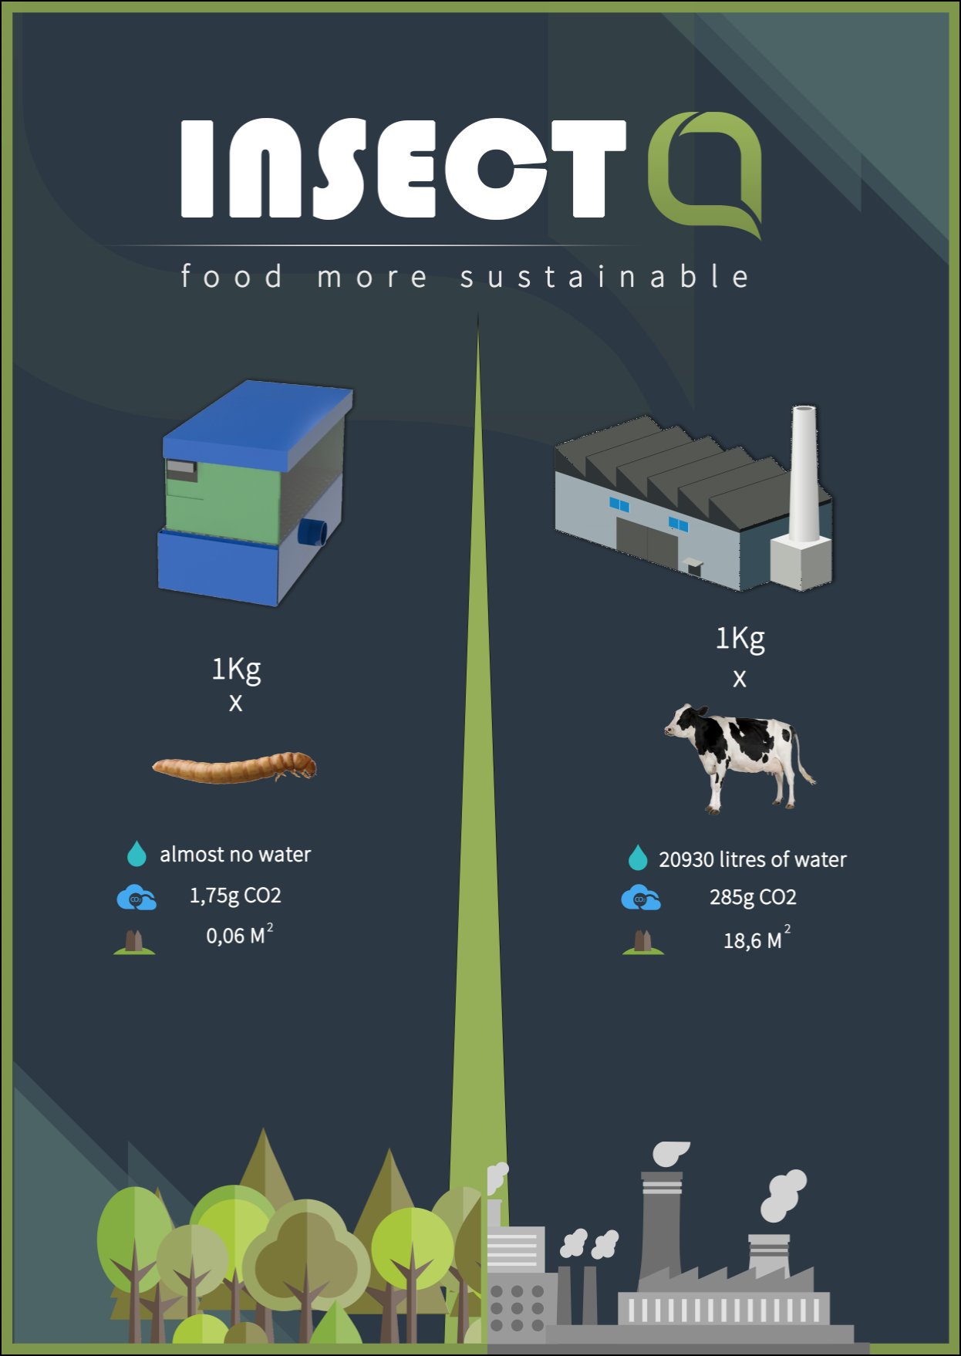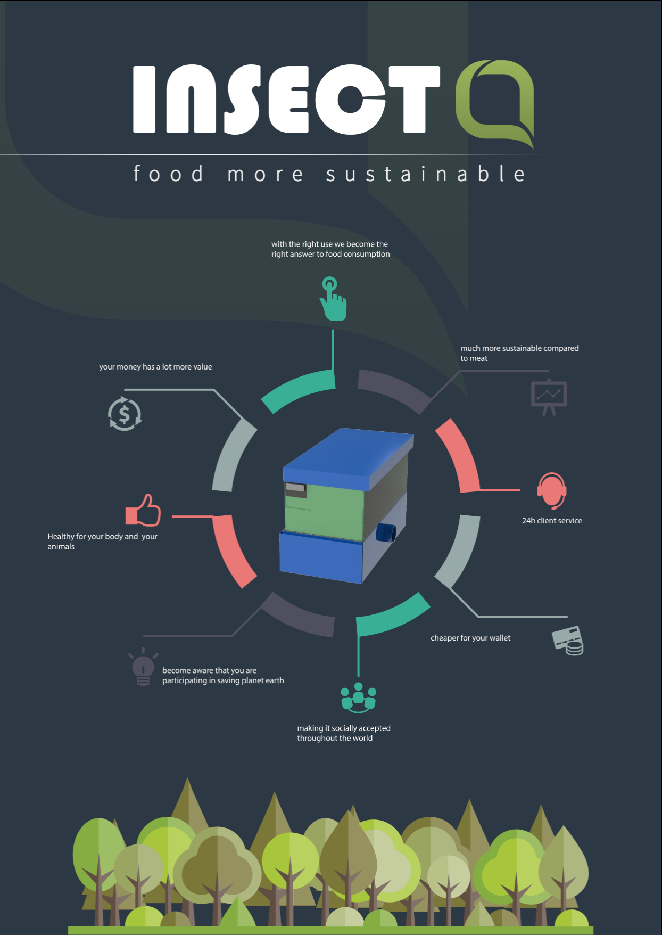
2. As we have change the PMMA for PVC, we are going to need a different glue. Do you have that glue in ISEP or we have to look for a store? Abel will provide the UHU Allplast glue.
3. We said that we are going to put a colour sticker in the PVC. Can we print those stickers in ISEP or we need a special printer/material? We need the dimensions of the blue and green plástico autocolante.

Minute:
We discussed about the best solution of our poster, what is missing, the writing too small, how much we can produce? After that we talked about the glue because we have to change it because of the materials. We searched for UHU. Forthermore we have to look after the dimensions of the insectarium for the color roles to make it a bit more atractive, till tomorrow.

14th Meeting (28.05.2015)

Agenda:
1. How much time is for each part of the final presentation? Same as in the interim? Do we have to present the poster?
Answer: 15 minutes including the video. You can end with the poster, but it should be self explanatory, i.e., does not require a presentation.
2. How we can get male-male jump wires?
Answer: The answer was sent by email yesterday.

Minute:
We should start building the Insectarium. The supervisors answered the question and after 10 minutes the meeting was already closed.

15th Meeting (04.06.2015)

Agenda:
1. What points do we need to put into the presentation (state of art, ethics, marketing, … every point one slide)?
2. Do we have to make tables for the tables and figures in the beginning?
Yes, in the final Word version it is mandatory.

Minute:
We dicussed the questions and talked about the presentation how we should structure it. Benedita explained us how to put the references into the wiki in the correct form. We should think about our connections of the electronical part and start to test all devices. Of course it is important to built the Insectarium faster now.

16th Meeting (11.06.2015)

Agenda:

Minute:
We're on the right track , follow the planning now and finish everything on the asked deadline.

Final Presentation (18.06.2015)

Activities
Start | End | Task | Description | Who
26.02.15 | 02.03.15 | choose the team-project | making a voting for each topic | all
02.03.15 | 03.03.15 | research | research for our target-market and discuss about it | all
03.03.15 | 04.03.15 | prepare for the first meeting with the supervisors | think about questions that are important to know for the project | all
02.03.15 | 08.03.15 | document the teammeetings | document in the weekly report what we´ve done in the group | Carina
05.03.15 | 05.03.15 | Meet each other for new tasks | to come further we dicuss about our ideas and give tasks to everyone | all
05.03.15 | 09.03.15 | research | research for the market, all about the insects and the exictings | Carina,Kristjan
06.03.15 | 10.03.15 | group-presentation | making the group-presentation for the “teambuilding-lesson” | Anthony
06.03.15 | 11.03.15 | Gantt Chart | making the hole Gantt Chart for the levy | Bartek
06.03.15 | 13.03.15 | leaflet | designing, preparing the leaflet for the portugues-class | Anthony
10.03.15 | 11.03.15 | giving tasks | meet each other for talking about the main tasks because of the timesaving | all
11.03.15 | 20.03.15 | electronic range | search for what we need for our insectarium | Eughan, Bartek
11.03.15 | 11.03.15 | drawing the idea | we discuss about how we can build the insectarium, the design | Paloma
11.03.15 | 11.03.15 | prepare for the 2nd meeting with the supervisors | which questions, asking for a meeting with our coordinator | all
11.03.15 | 27.03.15 | start working with the marketing plan | marketing analysis, segmentation, positoning | Carina
13.03.15 | 16.03.15 | make the writing in wiki for the state of art | like the living room, what they need and how they grow | Kristjan
13.03.15 | 20.03.15 | look for and decide for the devices for the insectarium | what is possible in general and what we decide for | Eughan, Bartek
16.03.15 | 20.03.15 | work on the design | make a drwaing on a programm for 3D of the insectarium | Paloma
17.03.15 | 17.03.15 | had a meeting with the client Abel | to get more information how our insectarium should look likeand which components we should instal | Carina, Kristjan, Eughan, Anthony
18.03.15 | 23.03.15 | prepare the presentation for the last energy and sustainability lesson | why and how is our product sustainable? referring to environmental, ecological, solzial and the life-cycle also introduction and conclusion | all
18.03.15 | 18.03.15 | making the material list | of the devices we will use with low power | Eughan, Bartek
25.03.15 | 25.03.15 | energy and sustainability presentation | last time talking about why we are sustainable with given improvements for the further presentations | Carina, Anthony, Eughan, Kristjan, Paloma
25.03.15 | 27.03.15 | Material list | decision for the devices of the insectarium | Eughan
26.03.15 | 26.03.15 | marketing plan | finished the first part for the marketing part and for the interim report | Carina
03.04.15 | 08.04.15 | work on the design and drawings of the insectarium | design the prototype and draw it with a computer programm | Paloma
05.04.15 | 08.04.15 | electronic devices | make the decisions for the electronical devices and mention them on the wiki | Bartek, Eughan
06.04.15 | 09.04.15 | work on the interim presentaion | design and write down the most important points of our toics for the interim presentation | Anthony
07.04.15 | 07.04.15 | prepare the presentation | we prepared ourselves by speaking the presentation | Eughan, Paloma, Anthony, Carina
09.04.15 | 09.04.15 | Interim Presentation | speak in fron of the teacher and present our most important points about our insectarium, on which we worked on since the last few weeks | Eughan, Paloma, Anthony, Kristjan, Carina
09.04.15 | 15.04.15 | improve the wiki | improve the points the teacher wanted us to, after the presentation | all
15.04.15 | 16.04.15 | Interim Report | make the interim report as a pdf with all improvements | Anthony
14.04.15 | 16.04.15 | State of Art | improve the state of art and add some stuff which was said in the interim presentation | Kristjan
10.04.15 | 20.04.15 | Marketing Mix | fill the wiki with the adapted marketing mix for the insectarium | Carina
10.04.15 | 20.04.15 | devices | decide for devices, check it, change again and discuss with client | Eughan
16.04.15 | 17.04.15 | dimensions | decide regarding to the devices the dimensions of the insectarium | Paloma
17.04.15 | 20.04.15 | project management | compile tables of the team for the pm-class | Paloma
22.04.15 | 10.06.15 | poster, video | start with designing the poster and video | Anthony
22.04.15 | 25.04.15 | summary | make the summary of her/his part for the paper | Kristjan,Carina
24.04.15 | 26.04.15 | sketches | designt a few skatches of the devises which are inside the insectarium | Bartek
24.04.15 | 24.04.15 | Ethic Task | 3rd Teamwork-to answer question and send by Email | Carina, Paloma, Bartek
28.04.15 | 28.04.15 | Abstract | Wrote the abstract for the paper with help from a guest teacher | all
10.05.15 | 20.05.15 | cardboar | building the cardboard and drew the devices on the the board | Paloma
20.05.15 | 10.06.15 | electronic part | working on installing and using the electronic parts | Bartek, Eughan
20.05.15 | 26.05.15 | materials | gone to shops and search for cables, finished the material list | Paloma
20.05.15 | 10.06.15 | paper | writing all parts of the paper and finish it | Carina, Kristjan
26.05.15 | 28.05.15 | Marketing | improfments of the teacher | Carina

